# RISE Math Placement Test Practice Test

**IMPORTANT NOTE:** This document strives to be ADA compliant. If you use assistive technology, please read the information provided in **Appendix A** for guidance on navigating this document and for access to the web version of this content.

## Math Tiers 1, 2, and 3

Overview

There are three RISE math placement tests. Students must earn a 70% on each test to advance to the next. That is, if students earn a 70% or higher on Test 1, then they can take Test 2. If students do not earn a 70% or higher on Test 2, then they cannot take Test 3.

Each test takes approximately 60 minutes to complete.

See the lists below of the content areas for each of the tests.

### Tier 1/Test 1

* Whole Numbers
* Fractions and Mixed Numbers
* Decimals
* Ratios, Rates and Proportions
* Percents
* Measurement
* Geometry
* Real Numbers

### Tier 2/Test 2

* Solving Equations and Inequalities
* Graphing
* Exponents and Polynomials
* Concepts in Statistics

### Tier 3/Test 3

* Factoring
* Rational Expressions and Equations
* Radical Expressions and Equations and Quadratic Equations
* Functions

The following pages contain sample test questions and an answer key organized by tier. During the practice test and real test experiences, students should use the [RISE Placement Test Formula Chart](https://docs.google.com/document/d/1IP-BNAGSKsslbPrN2OV5f0Dhyb7ZHFizAoHvtYX1G-w/edit) (https://docs.google.com/document/d/1IP-BNAGSKsslbPrN2OV5f0Dhyb7ZHFizAoHvtYX1G-w/edit).

# Tier 1 Practice Test Questions

## Whole Numbers

1. You open up a shop in Hawaii and want to offer customers four days of extreme experiences. On the first 2 days the customer can choose a water activity: snorkeling, fishing and water skiing. The next 2 days, the customer can choose from more extreme activities: zip lining, sky diving, rock climbing, and cave exploring. In how many ways can a customer choose a water activity for the first 2 days and then another water activity for last 2 days?
   1. 12
   2. 7
   3. 13
   4. 4
2. Constance wants brand new carpet for her square-shaped bedroom. Her bedroom is 11 ft. by 11 ft. How much carpeting will Connie need to purchase to cover half of the floor?
   1. 121 sq. ft.
   2. 60.5 sq. ft.
   3. 120 sq. ft.
   4. 65 sq. ft.
3. The Krispy Creme “donuts are ready” sign at three different Krispy Crème locations, lights up when the donuts are ready at every 10 minutes, 15 minutes and 20 minutes, respectively. If the time is 9:00 pm and donuts are ready at all three shops, how many minutes will it take for the signs to again light up at the same time?
   1. 30 minutes
   2. 40 minutes
   3. 50 minutes
   4. 60 minutes

(Test continued on next page)

Fractions

1. In *Figure 1*, below, there are 3 out of 5 triangles shaded blue. In *Figure 2*, below, there are 6 out of 10 triangles shaded blue. What fraction represents the total blue shaded triangles between Figure 1 and 2?
   1. 6/5
   2. 10/12
   3. 9/15
   4. 9/10

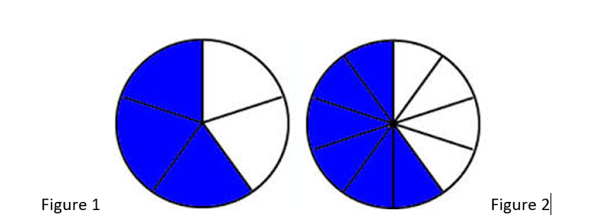

Figure 1



Figure 2

(Test continued on next page)

## Decimals

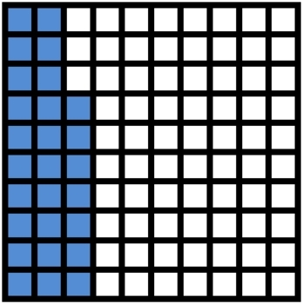

Figure 3

1. In *Figure 3*, above, the area of each square represents 1/100 of a square inch. As a decimal, which one of the following is true?
   1. Since the area of each square represents 1/100 of a square inch, then the portion of Figure shaded is representing 0.2 as an equivalent decimal.
   2. Since the area of each square represents 1/100 of a square inch, then the portion of Figure shaded is representing 0.27 an equivalent decimal.
   3. Since the area of each square represents 1/100 of a square inch, then the portion of Figure shaded is representing 0.25 as an equivalent decimal.
   4. Since the area of each square represents 1/100 of a square inch, then the portion of Figure shaded is representing 0.23 as an equivalent decimal.

## Ratios, Rates and Proportions

1. A lime sherbet punch can be made from 2 pints of lime sherbet and 4-liters of Ginger Ale. If I triple the lime sherbet, how many liters of Ginger Ale will be needed to make the punch?
   1. 10 liters
   2. 11 liters
   3. 12 liters
   4. 13 liters
2. The following prices for pecans are all in proportion except,
   1. $2 per oz. equals $6 per 3 oz.
   2. $4 per 2 oz equals $20 per 10 oz.
   3. $9 per 4.5 oz equals $36 per 18 oz.
   4. $13 per 6 oz equals $29 per 12 oz.

## Percent

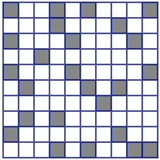

Figure 4

1. In Figure *4* above, what is the percent of unshaded blocks?
   1. 60%
   2. 65%
   3. 70%
   4. 75%
2. What is the discounted price for a pair of shoes that cost $ 75.00, if the discount is 25%?
   1. $55.00
   2. $56.25
   3. $57.50
   4. $58.00

(Test continued on next page)

1. What is the original cost of a sofa if it has been discounted 40% and the amount after the discount is $165.00?
   1. $275.00
   2. $660.00
   3. $231.00
   4. $412.50

## Measurement

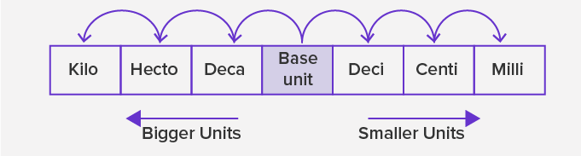

Figure 5

1. *Figure 5*, above, shows the relationship between metric prefixes. If the base unit is **meter**, convert 87,000 mm to km.
   1. 0.87 km
   2. 0.0087 km
   3. 0.087 km
   4. 0.00087 km
2. Laurence purchased a 200 ml bottle of juice and purchased a second 3-liter bottle of juice. What is the difference in liters between the two juice bottle amounts?
   1. 2.08 L
   2. 2.008 L
   3. 2.8 L
   4. 28 L

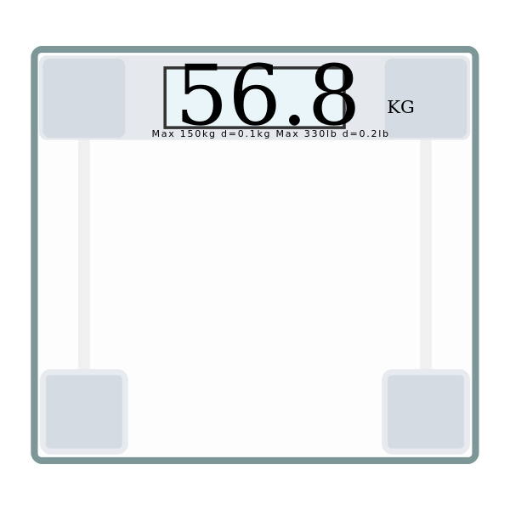

Figure 6

1. *Figure 6*, above, shows a digital scale and the weight of Ms. Roberson’s grandson, Romiin in kg. How many pounds is Romiin? (Round to the nearest whole number)
   1. 125 lbs
   2. 26 lbs
   3. 109 lbs
   4. 59 lbs

## Geometry

1. The circumference of a circle is given by the formula, , where .The radius of the tire of a Lexus is 17 inches. Find the circumference of the tire. Round your final answer to the nearest whole number.
   1. 227 inches
   2. 53 inches
   3. 907 inches
   4. 107 inches

(Test continued on next page)

1. Given the right triangle in *Figure 7* below, if a = 3 ft and c = 5 ft, find b, the missing side.
2. 3.5 ft
3. 2 ft
4. 4 ft
5. 16 ft

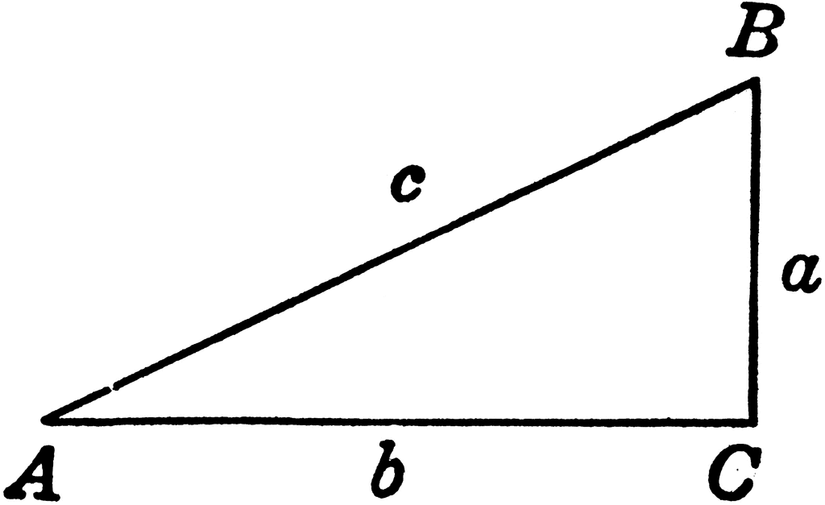

Figure 7

1. Evaluate: 
2. 84.5
3. -169
4. 13
5. 28,561

(Test continued on next page)

1. For Figure *8* below, find the perimeter of the polygon.

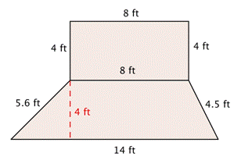

Figure 8

1. 48.1 ft
2. 52.1 ft
3. 40.1 ft
4. 76 ft

## Real Numbers

1. Simplify 
2. 6
3. 16.5
4. 4
5. 0
6. *Simplify* .
7. 21
8. -79
9. -9
10. 91

(Test continued on next page)

1. Translate and evaluate the expression, x divided by 4 plus 9, if x = 4.
2. 4/13
3. 10
4. 19
5. 1/13
6. Simplify the expression .
7. -9
8. 9
9. 1
10. -2
11. Simplify the expression .
12. 1/9
13. -7/18
14. 1
15. 0
16. Simplify .
17. 216
18. 18
19. -216
20. -18

(End of Tier 1 test)

# Tier 1 Answers and Explanations

## Whole Numbers and Fractions

1. ANSWER: **a**

This problem uses the basic principle of multiplication. The shop offers 3 different activities for 2 days to choose from and offers 4 more different activities for the next 2 days. Since the question wants to know how many extreme sports are possible, and since there are 3 on one experience and 4 on the others, then 3 x 4 = 12. There are 12 possible extreme activities to choose from.

1. ANSWER: **b**

This problem uses the formula for the area of a rectangle, *A = l x w*. In this case, the shape of the room is a square. So, the formula is modified, and the area of a square is *A = s x s.* To cover only half of the floor divide by 2. A = 11 x 11=121/2=60.5 sq. ft.

1. ANSWER: **d**

Applying Least Common Multiple (*LCM*) will solve this problem. For example, at one Krispy Cremes, the sign will light up every 10, 20, 30, 40, 50, 60 minutes. At the next donut shop every 15, 30, 45, 60 minutes. Lastly, at the third shop every 20, 40, 60 minutes. So, when the signals “are ready” lights up at the same 9:00pm, it will be in every 60 minutes. The *LCM* for 10, 15, and 20 is 60.

1. ANSWER: **a**

We can write figures 1 and 2 as fractions, 3/5 and 6/10. In order to add these two fractions, the denominators must be the same. You will need to find the Least Common Denominator (LCD) for fractions 3/5 and 6/10. Finding the multiples of 5, by counting by 5’s: 5, 10, 15, and so on. Finding the multiples of 10, by counting by 10’s: 10, 20, 30, and so on. Looking at the multiples of 5 and 10, 10 appears to be what both numbers have in common. Now we can use 10 to be the new denominator for each fraction. Since there is a new denominator, there should be a new numerator. The steps are as follows:

.

## Decimals

1. ANSWER: **b**

Since each square is 1/100. Counting squares that are blue, there are 27. So, we can write this as a fraction, 27/100. 27/100 can be written as 27 hundredths. Then writing as an equivalent decimal, 0.27.

Ratios, Rates and Proportions

1. ANSWER: **c**

There are two ratios, 2 pints :4 liters and 6 pints (2 x 3, tripled the amount of sherbet): L liters. Using proportions, and setting the two ratios equal to each other, it follows,

 .

By cross multiplying, 2 x L = 4 x 6. Multiplying both sides gives, 2L = 24. Solving for L, by dividing both sides by 2, gives, L = 12. So, it will take 12 liters of Ginger Ale for 6 pints of Lime Sherbet.

1. ANSWER: **d**

To see if two ratios are in proportion, first make sure we are working with the same units, dollars to ounces. Then we set the two ratios equal to each other. Take the cross products of the numerator to denominator which must equal. This show proportions. The multiple-choice answers that are in proportion are a, b, and c. d is not in proportion because, 13 x 12 = 6 x 29 does not equal the same number. Therefore, the prices are not in proportion of each other.

## Percent

1. ANSWER: **d**

By simply counting the unshaded blocks, there are 75 out of 100 blocks, unshaded. This represents 75% unshaded blocks.

1. ANSWER: **b**

To find the discount price, you first multiply the discount rate x the original price. So, multiply, ($75.00 x .25 = $18.75, remember to change your percent to a decimal by dividing by 100. Therefore, by subtracting $18.75 from the original price of, $75.00, equals the discount price of $56.25.

1. ANSWER: **a**

Note that since the discount is 40% of the original price, the price after the discount is 60% of the original price. The formula, Percent x Base = Amount can be used to find the original price, where Percent = 60% = 0.6, Base = original price, and Amount = $165. Substituting into the formula gives, 0.6 x original price = 165. Solving for the original price by dividing both sides of the equation by 0.6 gives $275.

## Measurements

1. ANSWER: **c**

Start counting from the decimal point in the smaller unit, 87,000 mm and move 6 spaces to the left until you get to Km. Now move the decimal, in the number 87,000, 6 places to the left also. Since this is a whole number, the decimal is behind the last zero in 87.000 mm. The conversion is equal to 0.087Km.

1. ANSWER: **c**

The two bottles must be in the same metric units. Convert 200ml to liters. Using Figure 5 above, this gives 0.2 L. Therefore, to find the difference, subtract, 0.2 from 3 and get, 2.8 L.

1. ANSWER: **a**

Converting 56.8Kg to pounds, multiplying by 2.2, (1 kg = 2.2 pounds), therefore, Romiin weighs 124.96 pounds. Rounding to the nearest whole number, the answer is 125 lbs.

## Geometry

1. ANSWER: **d**

The diameter of the tire is 2 times the radius, which is 34 inches. Using the formula above, C = 3.14 x 34 = 106.76. Rounding 106.76 to the nearest whole number gives 107. So, the circumference of the Lexus tire is 107 inches.

1. ANSWER: **c**  
   To find the missing side, b, use the Pythagorean theorem formula, . Replace a and c in the formula, with its respective values. Therefore,





 subtract 9 from both sides,

, take the square root of both sides,

.

1. ANSWER: **c**

Taking the square root of . So, the positive root is +13.

1. ANSWER: **c**

To find the perimeter of the polygon, add all sides around the shape. So, P = 4ft+8ft+4ft+4.5ft+14ft+5.6ft= 40.1 ft.

## Real Numbers

1. ANSWER: **a**

Translated as a mathematical expression, denoted as,



$.$

Following PEMDAS, ,

,



6

1. ANSWER: **d**

Following PEMDAS, and look for representation of parentheses, working from left to right, take the square root of 36, take the absolute value of -50, , continuing PEMDAS, left to right you add then subtract,

50 + 6 +35

56 + 35

91

1. ANSWER: **b**

Translated, we have, $.$ Since $.$

1. ANSWER: **a**

By following orders of operations, and working from left to right, take the square of 4, by multiplying 4 times 4, and the same for 5 squared. Then subtract the two from each other, as follows: 16 – 25 = -9.

1. ANSWER: **d**

Following orders of operations and working in parentheses first, subtracting the fractions gives, 6/6=1. Raising 8/9 to the zero power is 1. So 1 – 1 = 0.

1. ANSWER: **c**

To write in expanded form, is, - 6 x 6 x 6 = - 216. The expanded notation is not (-6)(-6)(-6) = -216. Although the answer is the same, the number is a positive 6 and not a negative 6.

# Tier 2 Practice Test Questions

## Solving Equations and Inequalities

1. Solve the equation below for *x*, .
2. x = -35
3. x = -17
4. x = 17
5. x = 35
6. Solve the equation below for *y*, .
7. y = - 49
8. y = 131
9. y = 49
10. y = - 46
11. Solve, 7*x* + 11 = - 73.
12. 12
13. 13
14. -13
15. -12
16. Solve: $.$
17. y = 7/8
18. y = 56
19. y = 8/7
20. y = 8
21. Which equation gives a solution of all real numbers?
22. x = 1
23. x = -1
24. 2x = 2x
25. 2x = 3x
26. Which equation matches the following: *Henry’s appetite is twice as big as Guy’s*? Assume H represents Henry’s appetite and G represents Guy’s appetite.
27. 2G = H
28. GH = 2
29. 2H = G
30. 2 + G = H
31. In the question above, if Guy can eat 2 full racks of baby back ribs, how many full racks of baby back ribs can Henry eat?
32. 1
33. 4
34. 3
35. 6

8. The diagram in *Figure 9* below shows 4 graphs of inequalities. Which graph shows ?

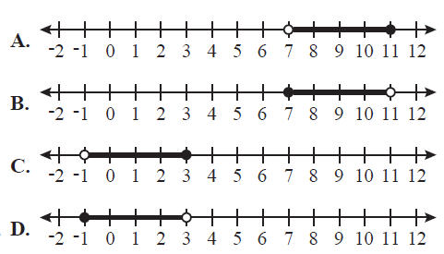

Figure 9

(Test continued on next page)

1. An iguana has to keep its body temperature between 75 degrees and 95 degrees (Fahrenheit). Write this as an inequality, where x represents the iguana’s body temperature.
2. 
3. 
4. 
5. 
6. When solving for *h* in  and then graphing the solution, there will be [----blank----] on the number line. (Fill in the blank.)
7. a closed circle
8. an open circle
9. an asterisk
10. a small square

## Graphing

1. The coordinate plain allows us to plot points. These points are represented by ordered pairs, *(x, y)*. *x* is called the domain and *y* is called the range. Given the following ordered pairs,

(1,2), (4,6), (8, 10), (12, 14).

What are the numbers in the domain?

1. {2, 6, 10, 14}
2. {1, 4, 8, 12}
3. {1, 6, 8, 14}
4. {2, 4, 6, 8}

(Test continued on next page)

1. In *Figure 10* below, Sponge Bob is drawn on the coordinate plane. In which quadrant is his red tie?
2. I
3. II
4. III
5. IV

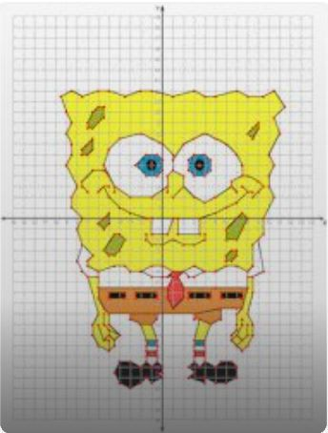

Figure 10

1. In a coordinate plane, in which quadrant will you find the ordered pair (-13,-5)?
2. I
3. II
4. III
5. IV

(Test continued on next page)

1. Which of the graphs blow represents a linear equation?

a. 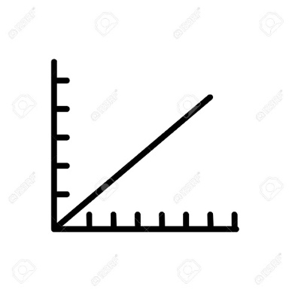 b. 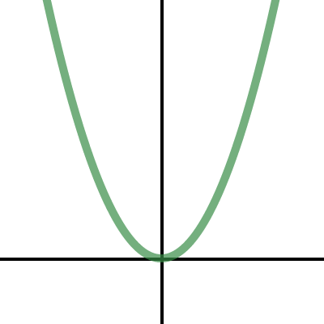

c. d. 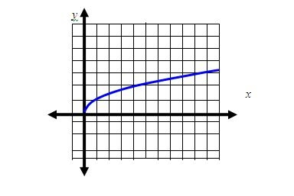

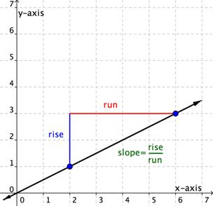

Figure 11

1. In *Figure 11* below, what is the slope of the given line in simplest form?
2. Slope is 2/4
3. Slope is ½
4. Slope is 4/2
5. Slope is 2/1
6. In the *Figure 12* graph below, assuming lines n and o are parallel, which two lines are perpendicular?
7. Lines m and o
8. Lines n and o
9. Lines l and m
10. Lines m and A

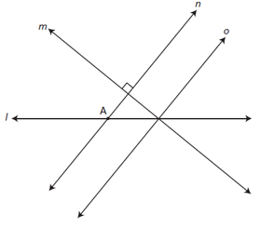

Figure 12

1. The formula, *y = mx + b,* can be used to identify the slope and y intercept of a line. Which variable in the formula represents the slope?
2. y
3. b
4. x
5. m
6. Determine the relationship between the lines, y = -2 and x = 5.
7. The lines are diagonal
8. The lines are supplementary
9. The lines are parallel
10. The lines are perpendicular

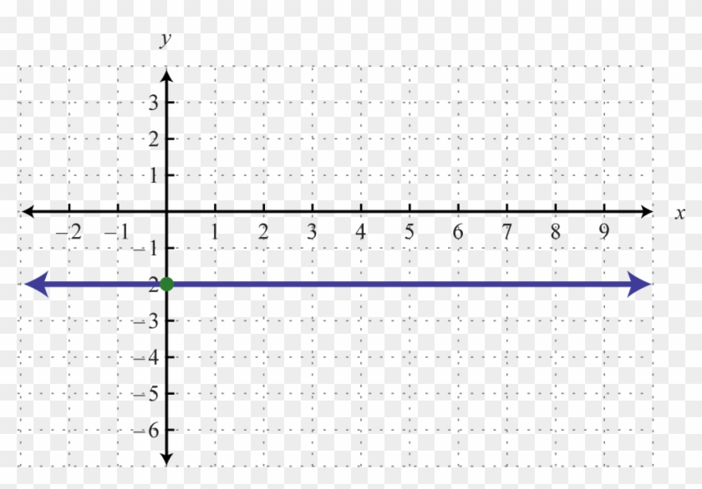

Figure 13

1. In *Figure 13* above, what is the slope of the blue line?
2. The line doesn’t have a slope.
3. m = 2
4. m = -2
5. m = 0

## Exponents and Polynomials

1. Evaluate the expression , where .
2. 1/8
3. -3/8
4. -5/8
5. 7/8
6. Given the polynomial expression , an example of a constant would be:
7. 5
8. 1
9. 6
10. 4
11. Add. 
12. 
13. 
14. 
15. 
16. Consider a polygon whose side lengths are described by (x+3) , (x+7) , 2x, 8x, and (-6x-8). Find the perimeter of this polygon.
17. 5x +1
18. 3x - 8
19. 2x + 6
20. 6x + 2

(Test continued on next page)

Concepts in Statistics

1. There are many types of graphical representations.Which graph records the number of observations in a set of data?
2. A Frequency Table  
   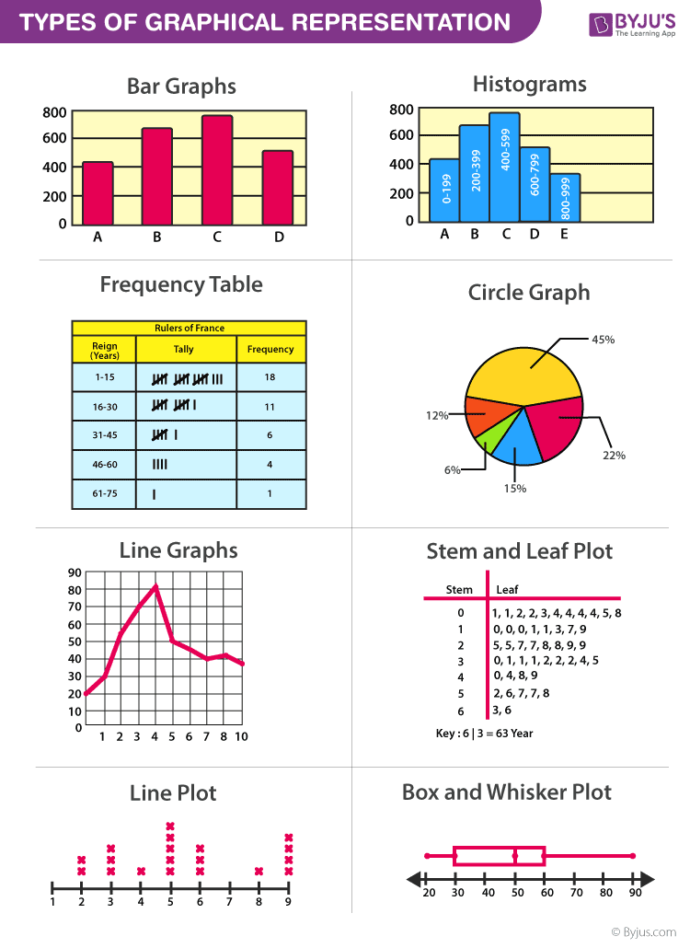
3. Bar Graphs

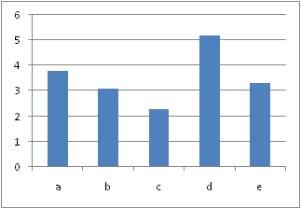

1. Box and Whisker Plot  
   
2. Circle Graph  
   
3. Find the **mean** of the following 5 NASCAR Motor Speedway tracks: Talladega 2.66 miles Pocono 2.5 miles, Atlanta, 1.54 miles, Bristol 0.533 mile, and Lowes (Charlotte) 1.5 miles.
4. 1.074 miles
5. 1.07445 miles
6. 1.7466 miles
7. 8.733 miles

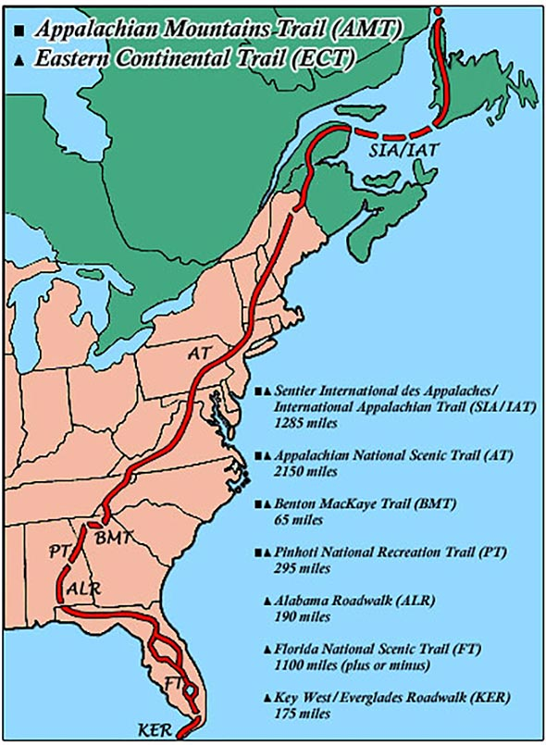

Figure 14

1. In *Figure 14* above, the map shows several US hiking trails. What is the **mode** of the miles given for the trails?
2. There is no mode.
3. 751.43 miles
4. 259 miles
5. 2085 miles

(Test continued on next page)



Figure 15

1. In *Figure 15* above, the square has the side length described by a polynomial expression. How many terms are this polynomial?
2. 1
3. 2
4. 3
5. 4

(End of Tier 2 test)

# Tier 2 Answers and Explanations

## Solving Equations and inequalities

1. ANSWER: **d**

Using the Addition property of Equality to solve for *x*, add 9(opposite of -9) to both sides. This is a one- step equation, so the solution for *x* = 35.

1. ANSWER: **a**

Using the Addition property of Equality to solve for y, subtract 41(opposite of -41) from both sides. This gives, , , divide both sides by -1. The solution for y = - 49.

1. ANSWER: **d**   
   Using the Addition property and multiplication property of Equality, this a two-step equation. So, , , , .
2. ANSWER: **c**  
   Applying the addition rule, add -4y to both sides and add 2 to both sides. This gives 7y = 8, dividing by 7 both sides, gives the solution, y = 8/7
3. ANSWER: **c**  
   To be all real number the solution shows the left side of the equal sign is equal to the right side of the equal sign. 0 = 0 shows this fact.
4. ANSWER: **a**  
   Translating into an equation, reading from left to right, Let H be Henry and G be Guy. Then the word “is” means equal to and the word twice means to multiply Guy’s appetite by 2. H = 2G.
5. ANSWER: **b**  
   Since G =2, then 2(2) = 4.
6. ANSWER: **c**  
   The graphs show that x has two solutions. and . An open circle is represented by the inequalities . A closed circle is represented by the inequalities .
7. ANSWER: **a**

This means that the temperature cannot go below 75 and above 95, but is can be any temperature between. Representing the temperature as random variable x, the solution and . Both are open circle because the two end points are not included as an allowed temperature.

1. ANSWER: **b**

Isolate the variable by adding 28 to both sides. . The graph of the inequality will be open since the inequality means “*h is greater than 56*”.

## Graphing

1. ANSWER: **b**

The numbers are 1, 4, 8, and 12. These are all the x coordinates, which represents the domain of x.

1. ANSWER: **d**  
   Sponge Bob’s red tie is in d. quadrant IV. The quadrants are counted in a counterclockwise direction beginning with the top right quadrant.
2. ANSWER: **c**

The point (-13, -5) is located in the lower left-hand corner, which is quadrant III. The quadrants are counted in a counterclockwise direction beginning with the top right quadrant.

1. ANSWER: **a**  
   There are a series of points on a straight line.
2. ANSWER: **b**  
   The slope is b, ½, since 3/6 = ½.
3. ANSWER: **a**  
   Three linear lines are cross each other in some way. In the above graph, lines b, c and d are crossing each other. Line b is being crossed by lines c and d. Lines c and d are crossing each other also. Therefore, these lines are perpendicular.
4. ANSWER: **d**  
   The lower-case *m* represents the slope of a line in the formula. The variable *x and y* represent the constants and the variable *b* represents the *y* intercept.
5. ANSWER: **d**

The line y = -2 is a horizontal line (slope is zero), whereas x = 5 is a vertical line (slope is undefined). Therefore, the two lines are perpendicular.

1. ANSWER: **d**

m = 0

One way to see that the slope of the given line is zero, is take 2 points on the line and use the slope formula to calculate the slope. For example, take the points (0 , -2) and (3 , -2). Using the slope formula gives:

.

Exponents and Polynomials

1. ANSWER: **b**  
   The negative exponent is the exponential rule to apply here. By taking the reciprocal of the  will make the exponent positive. Therefore, the expression becomes . Replacing x with 2 and evaluating gives .
2. ANSWER: **b**  
   The constant in this polynomial expression is 1. Since it is the term without a variable. The other numbers are called coefficients.
3. ANSWER: **a**  
   By removing the parentheses, grouping liked terms, adding and using laws of integers, equals,



1. ANSWER: **d**  
   By adding all sides of the polygon, you can find the perimeter and add all liked terms. Therefore, the Perimeter is .

Concepts in Statistics

1. ANSWER: **a**

A frequency table is the answer. It shows the number of times each data occurs by tally marks.

1. ANSWER: **c**

Adding all the values and divide by 5 is 1.7466. This is the mean.

1. ANSWER: **a**  
   There are no repeated numbers(miles). Thus, there isn’t a mode.
2. ANSWER: **d**  
   The polynomial expression has 4 terms. A polynomial is an algebraic expression that consists of monomials. In this polynomial, there are 4 monomials, therefore has 4 terms.

# Tier 3 Placement Test Practice Problems

## Factoring

1. Completely factor the following polynomial by first factoring out the GCF and then factoring the resulting trinomial.



* 1. 
  2. 
  3. 
  4. 

1. Factor. 
   1. 
   2. 
   3. 
   4. 

(Test continued on next page)

1. Factor. 
   1. 
   2. 
   3. 
   4. 
2. Find the factor that  and have in common.
   1. 
   2. 
   3. 
   4. 
3. Solve for x. 
   1. 
   2. 
   3. 
   4. 

(Test continued on next page)

1. A rectangular sheet of paper has an area of . If the length of the paper is  more than the width, what are the dimensions of the sheet of paper?
2. 
3. 
4. 
5. 

## Rational Expressions and Equations

1. Divide and simplify. 
   1. 
   2. 
   3. 
   4. 

(Test continued on next page)

1. Simplify and express the result in simplest form.



* 1. 
  2. 
  3. 
  4. 

1. Solve for x: 
   1. 
   2. 
   3. 
   4. 

(Test continued on next page)

1. The time it takes to travel a particular distance varies inversely as the speed traveled. If it takes a person 15 hours to travel from point A to point B at a speed of 60 miles per hour, how long will it take to travel from point A to point B at 75 miles per hour?
   1. 12 hours
   2. 30 hours
   3. 10 hours
   4. 18.75 hours

## Radical Expressions and Equations and Quadratic Formula

1. The formula for the volume of a sphere is , where V is the volume and r is the radius of the sphere. Solve the formula for r.
2. 
3. 
4. 
5. 

(Test continued on next page)

1. John and his little brother Kevin have a job that requires them to rake and bag leaves at a large house in their neighborhood. Suppose it takes John 2 hours to do the job alone and Kevin 3 hours to do the job alone. At these rates, how long will it take both boys to complete the job together?
2. 5 hours
3. 1.25 hours
4. 1 hour
5. 1.2 hours
6. Simplify: 
   1. 
   2. 
   3. 
   4. 
7. Simplify: 
8. 
9. 
10. 
11. 

(Test continued on next page)

1. Simplify: 
   1. 
   2. 
   3. 
   4. 
2. Rationalize the denominator and simplify the result. 
3. 
4. 
5. 
6. 
7. Solve for x: 
   1. 
   2. 
   3. 
   4. 

(Test continued on next page)

1. Solve for x using the Quadratic Formula: 
   1. 
   2. 
   3. 
   4. 
2. Use the discriminant to determine the number and type of solutions to the following quadratic equation.



1. one real solution
2. two real solutions
3. no solutions
4. two complex solutions

(Test continued on next page)

## Functions

1. What are the domain and range of the following function?



* 1. 
  2. 
  3. 
  4. 

1. What are the domain and range of the function 
   1. 
   2. 
   3. 
   4. 
2. Graph: 
3. 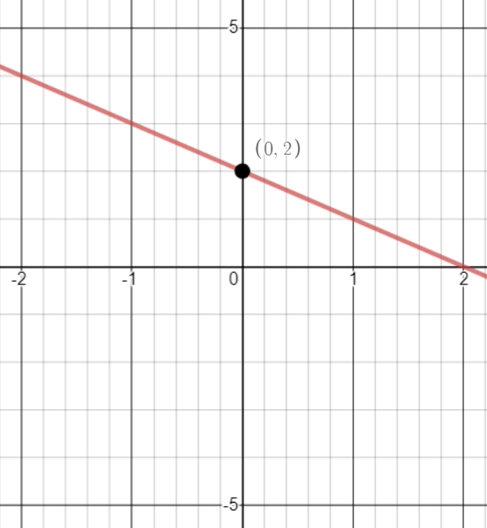
4. 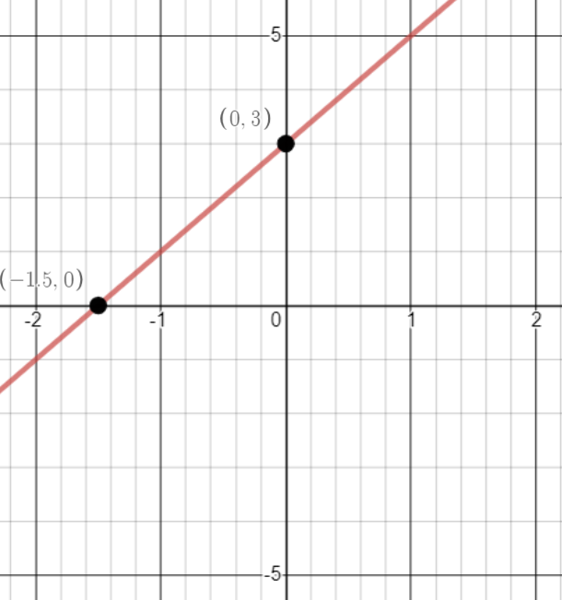
5. 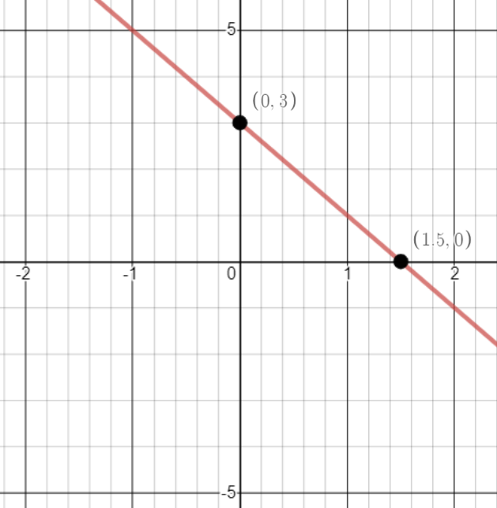
6. 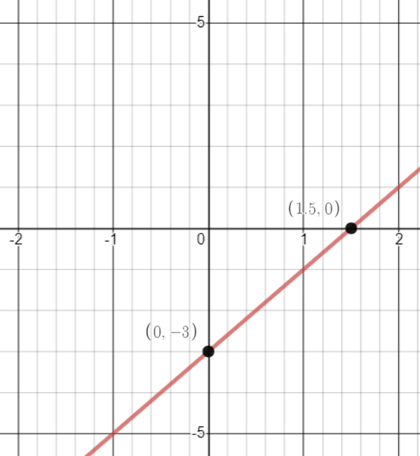
7. Which of the functions below is represented by the following graph?

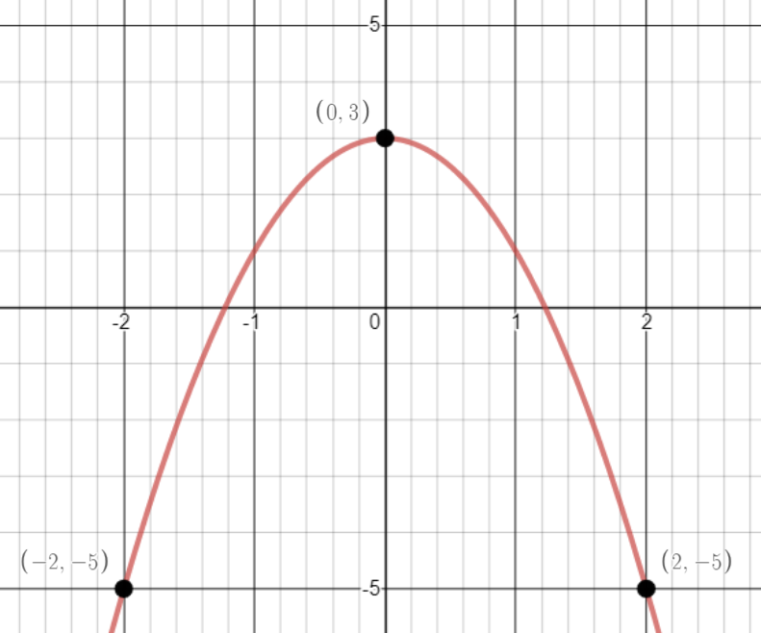

* 1. 
  2. 
  3. 
  4. 

1. Which function below has a graph that passes through all 4 of these points:



1. 
2. 
3. 
4. 
5. Given that , find .
   1. 
   2. 
   3. 
   4. 

(End of Tier 3 test)

# Tier 3 Answers and Explanations

1. ANSWER: **d**  
   The GCF for  is . When this is factored out of , this gives .

However, the resulting trinomial in parentheses, , is factorable. The trinomial factors into two binomials, .

So, the completely factored result is.

Note that you can use FOIL to verify that .

1. ANSWER: **c**  
   One way to see that this result is correct is by using FOIL or some other form of the distributive property:

F multiply first terms 

O multiply outer terms 

I multiply inner terms 

L multiply last terms 

Now simplifying, you have 

.

1. ANSWER: **d**  
    is a binomial that is classified as the difference of two perfect squares. This type of polynomial is always factorable. You can check that the answer given is correct by using FOIL:

F multiply first terms 

O multiply outer terms 

I multiply inner terms 

L multiply last terms 

Gathering terms and simplifying, you get 



1. ANSWER: **c**  
   For this problem, both  and need to be completely factored. Here are their factorizations:





The factor that both polynomials have in common is .

1. ANSWER: **d**  
   The given equation, , is a quadratic equation. One means to solve a quadratic equation is by writing it in standard form   
   () and then attempting to factor the trinomial on the left of the equal sign.

For the given equation, standard form is . Note that 20 was added to both sides of the original equation.

The trinomial to the left of the equals sign does indeed factor. So, in factored form, the equation becomes .

Setting both factors equal to zero and solving for x, you will get

.

You can see that these two solutions are correct by substituting them back into .

1. ANSWER: **a**  
   The equation that describes the information given in the problem is, where w represents the width of the sheet of paper. This is a quadratic equation that in standard form () becomes

.

To give an equivalent equation that doesn’t contain fractions, you can multiply both sides of the above equation by 2. The resulting equation is

.

The trinomial on the left can be factored and now gives



Setting both factors equal to zero and then solving for w, you get

.

Since the width can’t be a negative number, its value is . The length is  more than this, which is 10 in ().

1. ANSWER: **c**  
   To simplify , first write the problem in terms of multiplication, then factor the trinomials, and finally cancel common factors:



1. ANSWER: **b**  
   To simplify , the fractions need to be written with a common denominator. For this rational expression, the least common denominator (LCD) is .

Writing each fraction in terms of the , gives



Finally, factoring the numerator above gives

.

1. ANSWER: **b**  
   One way to solve the rational equation, , is by eliminating the fractions. This can be accomplished by multiplying both sides of the equation by the least common denominator (LCD) of the fractions. In this case, the LCD is 10.

Here is the result of multiplying both sides of the equation by 10 and then continuing to solve for x:



1. ANSWER: **a**  
   Since the problem deals with inverse variation, it can be modeled with the equation  , where t is the time, v is the speed, and k is proportionality constant.

Substituting  and  into the equation and then solving for k, this gives



So, now the general form of the inverse variation equation is



To find how long it will take to travel from point A to point B at 75 miles per hour, just substitute 75 for v in the general equation:



It will take 12 hours to travel from point A to B at a speed of 75 miles per hour.

1. ANSWER: **d**  
   The solution for this problem requires using algebraic steps to solve the volume formula, , for V:



(Explanation continued on next page)

The last step in isolating r is to take the cube root of both sides of the equation:



1. ANSWER: **d**  
   There’s more than one way to think about finding a solution to this problem, but here’s one approach:

Summarizing the information given in the problem, it takes John 2 hours to do the job alone, and it takes Kevin 3 hours to do the job alone.

This means that John could do 3 jobs in 6 hours and Kevin could do 2 jobs in 6 hours. In other words, together they could do 5 jobs in 6 hours. Using this rate to calculate the number of hours per job, you get

.

1. ANSWER: **c**  
   Simplifying the radical expression, , requires writing the radicand (part under the radical) in terms of perfect squares since the radical is a square root. Here is the radical simplified with perfect squares:



The factors highlighted in red are perfect squares, which means that when the square root is taken, the result will be the portion inside parentheses. So further simplifying, you will get



This appears to be the solution, but it isn’t. You were told at the beginning of the problem that , but you were not told anything about the variables x or y. In fact, they could be negative numbers. If y, in particular, is negative then the above solution is incorrect.

So, since we don’t know whether y is negative or positive, the correct solution is

.

Watch this [Absolute Value with Radicals video](https://www.youtube.com/watch?v=dqek7EkXcYo) (https://www.youtube.com/watch?v=dqek7EkXcYo) for a detailed explanation of why absolute value bars are necessary for the result.

1. ANSWER: **a**  
   For this problem, since , the final result won’t require any absolute value bars, as was the case in problem #13. To simplify , distribute and continue simplifying:



1. ANSWER: **a**  
   To simplify the given radical expression, , the radicand (expression under the radical symbol) needs to be expressed in terms of perfect cubes, since the radical is a cube root:



The factors in red are perfect cubes, and once the cube root of these is extracted, the result will be the expression inside the parentheses. So, simplifying further, you have

(Explanation continued on next page)



Note that since the original radical is a cube root (index is odd), there won’t be a need for absolute value bars in the final answer. In short, when the index of a radical is odd (cube roots, 5th roots, etc.), or the variables in the radicand are all positive, absolute value bars won’t be necessary in final result.

1. ANSWER: **d**  
   To rationalize the denominator in , means to get rid of the radical in the denominator. This is achieved by multiplying the numerator and denominator of the radical expression by  and then simplifying:



1. ANSWER: **b**  
   To solve for x, isolate the radical expression so that it is alone on one side of the equation:



Now, just square both sides of the above equation. This will cancel the square root.



1. ANSWER: **b**  
   The Quadratic Formula will be used to solve . This can be obtained from the provided formula chart:  .

The first step in obtaining the solution is to write the given quadratic in standard form (). This gives



From here, identify the constants, a, b, and c, to substitute into the Quadratic Formula.



(Explanation continued on next page)

Substituting these values in the Quadratic Formula gives:



Thus, the solutions are .

1. ANSWER: **d**  
   To determine the number and type of solutions for ,

the discriminant will be used. The discriminant is the expression under the radical in the Quadratic Formula: .

When , the given quadratic equation will have one real solution.

When , the given quadratic equation will have two real solutions.

When , the given quadratic equation will have two complex solutions.

For , . Substituting these values

into the discriminant gives:



This negative result for the value of the discriminant means that 

will have two complex (not real) solutions.

1. ANSWER: **b**  
   In the function, , the domain is the set of all x-values, and the range is the set of all y-values. For example, in the ordered pair, , 5 would be in the domain, and -8 would be in the range.

Considering all the ordered pairs in the function, the domain and range are



Note that although -8 and 2 are found in more than one of the ordered pairs, these values should only be included once in the range.

1. ANSWER: **c**  
   The domain and range for  can most easily be determined by observing its graph, which looks like the graph below.

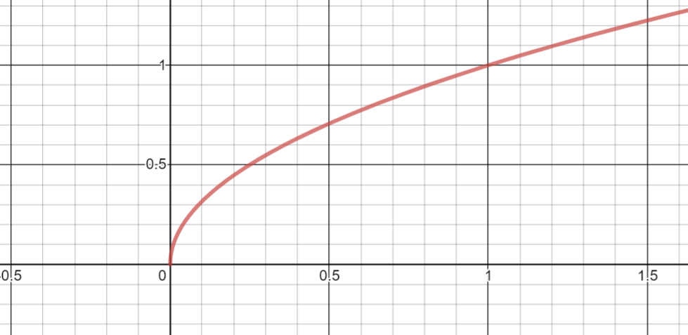

The domain of the function is the set of all x values, which from looking at the graph are numbers bigger than or equal to zero. The y values are also numbers bigger than or equal to zero. Symbolically, this is written



Note that f(x) represents the y values.

1. ANSWER: **c**  
   To graph , note that the equation is given in slope-intercept form,  (see the provided formula sheet).

In this form, m is the slope, and b is the y-intercept. So, for the given equation,

the slope is -2 and the y-intercept is 3. So, you should expect the graph to cross

the y-axis at 3 and have a negative slope (the line falls when proceeding from left

to right). Also, the slope can be thought of in terms of the rise over the run.



See how these quantities play out on the correct graph below.

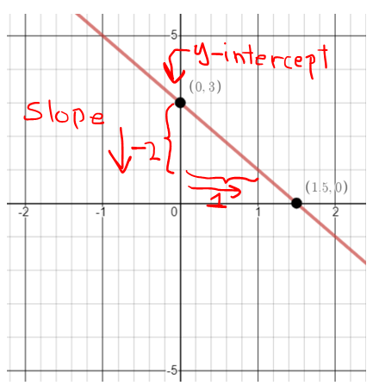

1. ANSWER: **b**  
   The graph given is in the shape of a parabola (think of a bowl shape) and has a vertex at the point (0,3). Note that this point is also the y-intercept. Due to the graph being a parabola, this means that it was formed from a quadratic equation, which has general form of . In this form, the vertex is given by

. (This vertex formula can be found on the provided formula sheet.)

Also, when the leading coefficient, **a**, is negative, the parabola turns downwards, which is the case for the graph in the problem. So, for the choices given in the problem, only b. and c. are possible solutions since the first terms in each are negative.

Finally, note that the graph passes through the points . So, these two points would need to satisfy the equation describing the graph. The only equation where this is true is :



1. ANSWER: **c**  
   To find which function passes through all 4 points, you could take each function and substitute each x-value into the function and show that the corresponding y-value is obtained. In short, you would be using a process of elimination. Here’s what this process looks like for :

Recall that the points are .



This shows that all the points satisfy . This is not the case for the other functions given.

1. ANSWER: **a**  
   Given that , find .

The solution is obtained by substituting  for x in :



# Appendix A

This Word Document contains various Math problems created using the MathType software from Design Science. For more details about MathType, please visit: [MathType by Design Science](http://www.dessci.com/en/products/mathtype/).

## NVDA Users

NVDA users have a couple of options to help ensure an optimal experience with this document:

* **Option A: Use the web version of the placement tests:**

[RISE Math Placement Test Practice Tests (web version)](https://sakai.durhamtech.edu/x/Alxw0O)

* **Option B: Download and install** the free [MathPlayer](https://www.dessci.com/en/products/mathplayer/) from Design Science. After installing MathPlayer, close and then reopen this document.

## JAWS or Fusion Users (and Refreshable Braille Display Users)

1. Make sure you are running JAWS 2019.1904.60 or Fusion 2019.1904.22 or higher along with Microsoft Word from Office 365. Note that
2. Install [MathType](http://www.wiris.com/) and activate the software as a trial or actual license.
3. In Settings Center for JAWS, make sure the "Use Accessibility Driver for Screen Capture" check box is selected. To access Settings Center, open Chrome and press **INSERT+F2.** **ARROW DOWN** to Settings Center and press **ENTER**.

Once you have the above criteria met, you can navigate to the formulas an expressions in this document, and while the cursor is on the formula, press the JAWS layered command: **INSERT+SPACEBAR, =**.

***Note:*** *The first time you do this, there will be a bit of a delay before the Math Viewer (described below) opens. It will be faster on subsequent uses.*

This will put you into a JAWS generated Math Viewer. You can then navigate and press **ENTER** on the various components, drill down into individual sections of the equation using the **ARROW** keys. When you press **UP ARROW**, you will move back one level.

With a refreshable Braille Display, and JAWS set to Contracted English US or UEB, the math equation will also be output in Nemeth for English Language versions.

### Using an Older Version of JAWS or Fusion?

Use the web version of the placement tests:[RISE Math Placement Test Practice Tests (web version)](https://sakai.durhamtech.edu/x/Alxw0O).