Durham Technical Community College
Faculty AI Guidelines

For Academic Year 2026-2027
Artificial Intelligence (AI) technologies are increasingly integrated into higher education, workplaces, and everyday life. Durham Technical Community College recognizes the potential of AI to enhance teaching, learning, creativity, productivity, accessibility, and workforce readiness.
The purpose of these guidelines is to assist faculty in implementing Durham Tech's Academic Integrity Policy by providing practical guidance for the responsible, ethical, transparent, and equitable use of AI in teaching and learning.

Introduction 2
Durham Tech’s Approach to Artificial Intelligence (AI): 2
Guiding Principles for Faculty: 2
Faculty and Student Responsibilities 3
Language of the Academic Integrity Policy 3
Expectations for Employee Use of AI 3
Expectations for Student Use of AI 3
Expectations for Both Employee and Student Use of AI 4
Privacy and Data Protection 4
AI Detectors 5
Ensuring Equitable Access 6
Ethical Use Decision Tree 7
Syllabus statements/ AI Acceptable Use Statements 8
Attribution and Disclosure Statements 9
Verification 10
Durham Tech’s Continuous Review of Faculty AI Guidelines 10

Introduction
These guidelines are intended to support faculty decision-making while preserving academic freedom and recognizing the diverse learning outcomes across disciplines.
- These Guidelines serve as a roadmap for faculty on how best to support interactions with AI as faculty.
- These guidelines provide the "how" and structure to support the Academic Integrity Policy while allowing for flexibility in variations of subject matter.
- The expectation is that these guidelines can be used as presented or adapted for various pathways and disciplines.
- The Academic Integrity Policy follows rigorous exploration of academic perspectives across the college and is in alignment with academic integrity policies in the State Board of Community Colleges Code to further support our SACSCOC accreditation
- The Academic Integrity Policy takes precedence over the Faculty AI Guidelines. Reference https://www.durhamtech.edu/policies-and-procedures/academic-integrity with any questions on the Academic Integrity Policy and for the Academic Integrity and Plagiarism Notification form.

Durham Tech’s Approach to Artificial Intelligence (AI)
Durham Technical Community College adopts a human-centered approach to artificial intelligence.
- AI should support, not replace human learning, critical thinking, creativity, professional judgment, and authentic demonstration of competency.
- The College encourages responsible and innovative uses of AI while maintaining:
  - Academic integrity
  - Human accountability
  - Transparency
  - Privacy and security
  - Equity and accessibility
  - Student learning outcomes
- All members of the Durham Tech community remain responsible for the accuracy, originality, and ethical use of AI-assisted work.

Guiding Principles for Faculty
Faculty are encouraged to evaluate AI use through the following principles:
- Mission Driven: AI use should be aligned with program and course learning outcomes.
- Human Oversight and Professional Responsibility: Humans remain responsible for decisions, judgments, and work products.AI-generated information should always be evaluated and verified.
- Academic Integrity: AI use should support authentic learning and honest demonstration of knowledge and skills.
- Fairness and Transparency: AI use should be clearly disclosed when required. All students should have equitable access to approved AI-supported learning opportunities.
- Privacy, Data Protection and Security: Sensitive information should never be entered into public AI tools.
- Responsible Innovation and Stewardship of Resources: AI should be used thoughtfully, taking into consideration sustainability and impact.

Faculty and Student Responsibilities
Faculty are expected to:
  - Clearly communicate AI expectations in their syllabi.
  - Clearly indicate AI expectations for each assignment.
  - Model responsible and transparent AI use.
  - Verify the accuracy of AI-generated instructional materials.
  - Consider equity and accessibility when selecting AI tools.
  - Promote AI literacy and critical thinking.
  - Protect student privacy and institutional data.
Faculty retain discretion in determining how AI may or may not be used within their courses.
Students are expected to:
  - Review course-specific AI expectations.
  - Follow assignment-specific AI requirements.
  - Verify AI-generated information.
  - Disclose AI use when required.
  - Maintain responsibility for all submitted work.
  - Adhere to Durham Tech's Academic Integrity Policy.
Students are encouraged to ask instructors for clarification when uncertain whether AI use is permitted.

Language of the Academic Integrity Policy

Expectations for Employee Use of AI
To reduce any ambiguity surrounding appropriate uses of generative Artificial Intelligence (AI), employees should clearly outline the policy for the use of generative AI tools in each course syllabus. Expectations for each assignment should be clearly indicated. Different instructors may permit different levels of AI use which will be noted in the course syllabus. To model appropriate, transparent, and ethical use of AI, employees are expected to disclose any use of AI in their classwork to students.

Expectations for Student Use of AI
- Students are expected to review the syllabus for each course in which they are enrolled to understand the AI policy for each course and that different instructors may permit different levels of AI use. Different instructors may permit different levels of AI use which will be noted in the course syllabus. (Faculty should list allowable as well as unallowable AI platforms)
- If used in any capacity for an assignment, generative AI requires proper acknowledgement according to the instructor's instructions for all generated work.
- If a student is unsure of any policy or any assignment-specific directions – including whether a tool is considered generative AI – students should reach out to their instructor for clarification prior to using the technology or completing the assignment.
- Students are responsible for verifying the accuracy of citations and references used in their writing and may be asked to verbally explain the assignment and writing process during in-class discussions and/or in a one-on-one meeting with the instructor. Regardless of whether the use of generative AI is permitted or prohibited for an assignment, students are expected to adhere to Durham Tech’s Academic Integrity Policy.

Expectations for Both Employee and Student Use of AI
Everyone should avoid inputting personal, confidential, or sensitive data into public AI tools. Data privacy examples are included in the next section.
Privacy and Data Protection
Faculty and students should avoid entering confidential, private, or sensitive information into public AI systems. Examples include:
- Student Information
  - Grades
  - Student ID numbers
  - Educational records
  - Accommodation documentation
- Employee Information
  - Personnel records
  - Performance evaluations
  - Employment documents
- Protected Information
  - Social Security numbers
  - Financial information
  - Protected health information
  - Confidential institutional data
Whenever possible, faculty should utilize institutionally supported tools such as Microsoft Copilot, which operates within Durham Tech's enterprise security environment.

AI Detectors
Faculty Considering using AI Detectors Should Assume AI Detectors are inaccurate. AI detection tools have significant limitations and should not be used as the sole basis for determining academic misconduct. AI detectors are not 100% accurate. For example, Canvas includes the Turnitin tool which has a 98% accuracy rate and may miss approx. 15% of AI-generated text. What can Faculty do Instead?
- Consider the Preparation as Worth More than the Detector
  - Adapt assignments to focus on critical thinking, processing, and personal application.
  - Incorporate Multimodal Elements: Assign projects that require students to create infographics, podcasts, or short videos to demonstrate their understanding of course concepts.
  - Require Personal Artifacts, such as brainstorming notes, outlines, rough drafts, and final reflections. Ask students to cite specific class discussions.
  - Use tools like "Version History" or the Draftback extension to view a time-lapse of how the student physically typed and edited the paper.
  - Integrate Procedural Assessments: Have students perform tasks or explain concepts live in class or require them to record themselves doing a hands-on procedure.
- Handling Suspected AI Submissions: When a student's work is flagged or looks suspicious, NCCCS guidelines recommend the following steps before pursuing academic integrity sanctions:
  - Refer to the Durham Tech Academic Integrity Policy. https://www.durhamtech.edu/policies-and-procedures/academic-integrity
  - Review the Evidence Holistically: Assess if the writing is missing personal touches, emotional depth, or reflects factual inaccuracies that AI is known to hallucinate.
  - Talk to the Student: Have a constructive, one-on-one conversation with the student about their submission and ask them to explain their main points or research process.
  - Check the Context: Note whether the submission deviates from the student’s normal writing style and vocabulary.
- In creating Projects or Evidence of Learning:
  - Encourage Effective Learning Strategies: Educate students on evidence-based techniques like retrieval practice and metacognition. Remind them that over-reliance on AI hinders the development of fundamental skills needed for their futures. Faculty should rely on multiple forms of evidence, including assignment artifacts, process documentation, student conversations, and demonstrated understanding
  - Slow Down the Reading Process: Use "social annotation" tools to make reading a collaborative, inquiry-based activity. Other methods include "commonplacing" (recording and interacting with quotes in personal notes) and creating concept maps to visualize relationships between ideas.
  - Focus on the Process, Not Just the Product: Scaffold writing by breaking large assignments into smaller parts, such as exploratory writing, draft theses, and peer reviews. Utilizing version history in tools like Google Docs can also help track progress.
  - Embrace Active and Experiential Learning: Incorporate real-time knowledge checks, such as "exit tickets". Assign experiential projects, like field studies or lab work, which rely on direct human experience that AI cannot access. Collaborative, project-based learning also adds an element of peer accountability.

Ensuring Equitable Access
Ensuring equitable access to AI in Durham Tech classrooms is essential since our students come with diverse backgrounds. These may include differences in technological resources, digital literacy levels, and financial capacities. Without intentional planning, AI use can widen existing achievement gaps and exclude learners who cannot afford premium tools. Faculty should evaluate both free and paid AI tools to ensure comparable functionality, accessibility, privacy protections, and inclusive design. Providing low-cost or institutionally supported options helps guarantee all students can participate fully, develop AI literacy, and meet learning outcomes without financial or technological barriers. Equity-focused choices promote fairness, student success, and ethical instructional practice for all learners. When comparing free vs paid tools think about the following aspects of each:

Free Tools | Paid Tools
- Have basic Features and Limits  - Often funded by ads or collecting user data  - From an ethical point of view, free tools can raise concerns about how your data is used, whether users truly agree to that use.  - Systems may show bias. | - Offer more advanced features  - Are more dependable  - Tend to protect your privacy better  - Privacy protections vary by the provider

Note: All students and employees have access to the basic versions of Copilot within our college’s Microsoft 365 license, which includes similar enterprise-wide data protection to other Microsoft products used.
To ensure equity, faculty will ensure:
- No assignment requires purchase of a paid AI subscription;
- Students are not graded on their ability to access premium AI features;
- Equivalent no-cost alternatives are available, where possible to mitigate student costs; and
- Accessibility considerations are reviewed before selecting AI tools.

Ethical Use Decision Tree
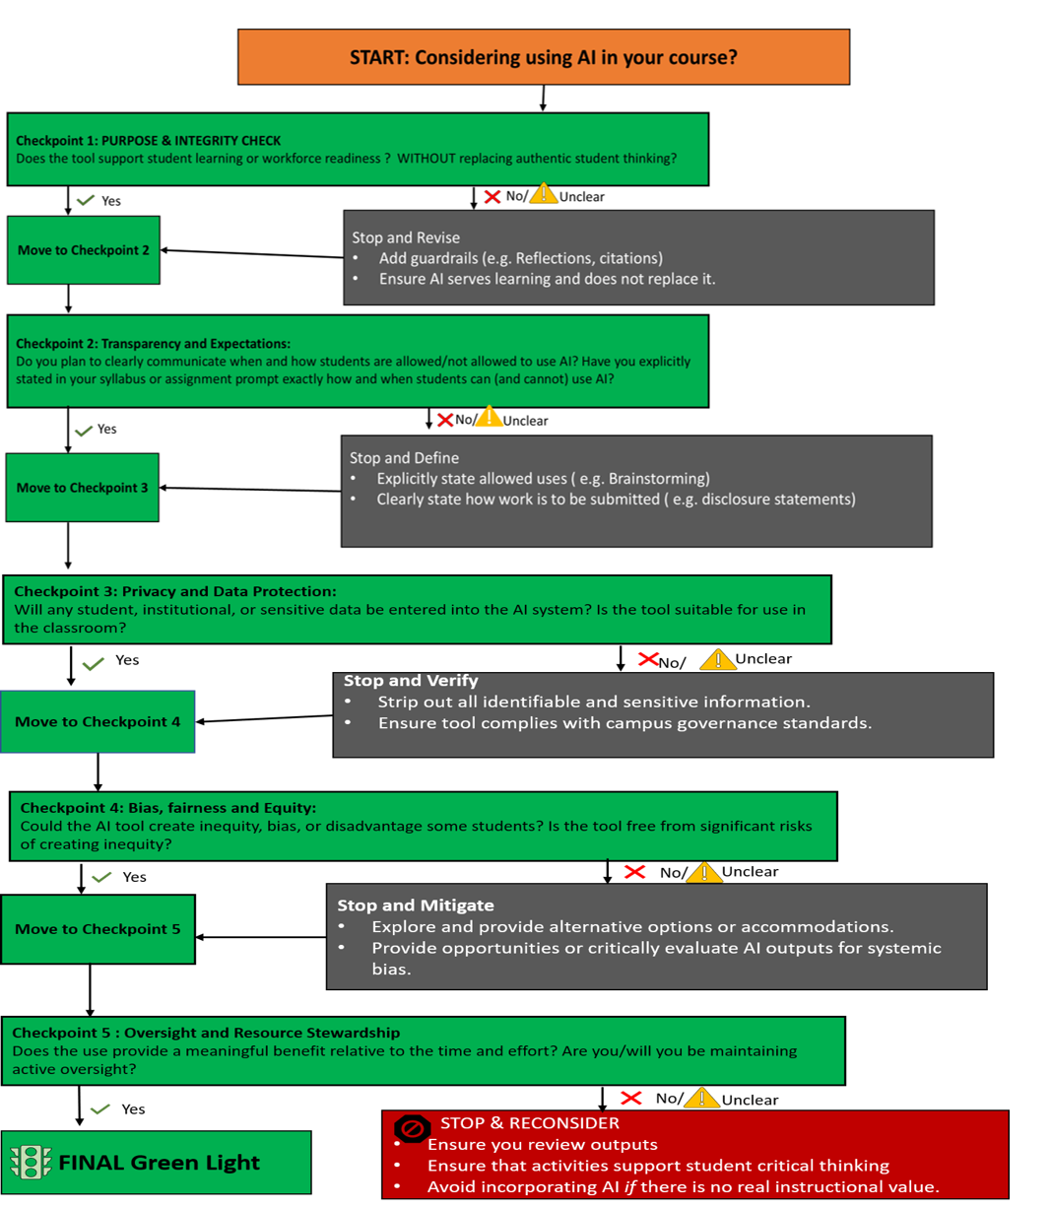
As you think about including AI in your course use the following decision tree.

Syllabus Statements/AI Acceptable Use Statements
Following the TRAIT framework and Guidance on AI use from NCCCS*, faculty should be clear in their Syllabus on where and how much AI is allowed in their courses/assignments. This is dependent on your specific content area, i.e., faculty may not allow students to use AI to solve math problems on a test. Below is a chart to ensure your syllabus language aligns / is consistent on the AI Use categories across the college.
Category | Description | Example of Acceptable Use | Example Assignment Statement
AI Prohibited | AI tools are not permitted; all work must be completed independently by the student. | For example, a student writes a paper or solves a math problem entirely on their own without any AI assistance. | "AI cannot be used at any stage of this assignment. This assignment is designed for you to demonstrate your own thinking, reasoning, and writing, even if your work is imperfect. Use of AI in any part of the assignment process will result in a grade of zero for the assignment."
AI Assisted | AI tools are allowed for non-content-generating tasks, such as grammar checks, spell checks, document formatting, or document organization. AI may not be used to create new content. | A student can use AI to check spelling and to format citations for a history paper.  The student can use AI to organize data for a lab report, but not to write a paper or lab report. | "AI can be used only to support grammar, spelling, or formatting in this assignment. The focus of the assignment is your critical thinking, not perfect mechanics. AI may not be used to generate or rewrite your ideas or content. Submitting AI-generated content as your own will be treated as plagiarism and will result in a grade of zero."
AI Supported | AI allowed to complete specific aspects of the task. Areas of the assignment or task are explicitly detailed for the students. | Students can use AI to generate specific parts of the literature review, such as a references table. AI allowed to suggest code for a program so a student can edit and improve it further. | "Students can use AI to generate specific parts of the assignment and ensure the areas supported by AI are attributed and disclosed clearly. You can use AI to brainstorm or to review your written work."
AI Integral | AI is a key tool in completing tasks. AI serves as a crucial element in the completion of the assignment/project. | Design an interactive AI Chatbot to support healthcare discussions with non-English speaking patients. Use an AI writing tool to generate story ideas or dialogue while revising the output and reflecting on AI contributions. | "You will use a generative AI tool during this project. You can use a free GenAI tool of your choice or Microsoft Copilot through your student account. You will not be required or expected to pay for any AI tool, subscription, or upgrade.  Do not enter personally identifiable, private, or sensitive information into GenAI prompts."

Attribution and Disclosure Statements
Sample Student AI Disclosure Statements: Note these are sample disclosure statements and can be adapted and used in instructor classrooms where appropriate.

AI Disclosure Statement (No AI Use):
I did not use artificial intelligence tools (such as ChatGPT, Copilot, Gemini, or similar) to complete this assignment. All ideas, writing, analysis, and revisions are my own.

AI-Assisted (Human-Led Work) Disclosure Statement:
I used artificial intelligence tools to support my work on this assignment. AI was used for brainstorming, organizing ideas, feedback on drafts, or editing for clarity and grammar. I wrote the content, made final decisions, and reviewed all AI suggestions for accuracy. This work represents my own understanding and effort.
AI tool(s) used: __________
Purpose of use: __________

AI-Generated with Instructor Permission Disclosure Statement (AI-Generated, AI-Integral):
This assignment includes content generated by AI, as allowed by the assignment instructions. I used AI to generate content and then reviewed, selected, edited, and verified the output. I understand that I am responsible for the accuracy, quality, and integrity of this work.
AI tool(s) used: __________
How I reviewed or modified the AI content: __________
**Important: AI rules may change by class or assignment. Always follow your instructor’s instructions. When unsure, ask before submitting.

Sample Faculty AI Use Disclosure Statement:
Portions of this instructional material were developed with the assistance of generative AI. All content was reviewed, revised, and verified by the creator prior to use.
Verification
Remember AI hallucinates! Faculty and students are encouraged to always verify AI output.
Verification and Hallucinations by Students and Faculty:
Faculty are Encouraged to (when engaged in Research and Scholarly Work):
  - Follow publisher requirements
  - Verify all references
  - Disclose AI assistance when required
  - Protect confidential research data
  - Avoid uploading unpublished manuscripts into public AI systems
Students are Encouraged to Verify Before You Trust; AI systems may:
  - Fabricate citations
  - Create nonexistent references
  - Generate incorrect facts
  - Produce biased outputs
  - Present misinformation confidently

Faculty and students remain equally responsible for verifying information through authoritative sources.
Durham Tech’s Continuous Review of Faculty AI Guidelines:
- Artificial intelligence technologies evolve rapidly.
- These guidelines will be reviewed periodically by Durham Tech leadership and appropriate stakeholders to ensure continued alignment with:
  - Durham Tech policies
  - NCCCS guidance
  - State Board Code
  - SACSCOC expectations
  - Emerging best practices

References
Spring 2025 – Developing AI Guidance for Faculty. UNC Chapel Hill. Https://www.ai.unc.edu/ai-guidance-for-faculty
August 2025 – AI Acceptable use Framework for Academic Tasks, Medical University of South Carolina, Center for the Advancement of Teaching and Learning. https://education.musc.edu/education-innovation/catl
December 2025 – AI Guidance Handbook for NC Community Colleges, NC Student Success Center Administration. https://opennccc.nccommunitycolleges.edu/courseware/lesson/1738
2026 – Brandeis University Syllabus Statements along four levels of AI use, https://www.brandeis.edu/teaching/online-guides/syllabus/ai-statements.html
2026 – Strategies for Designing AI Resistant Assignment, University of Chicago. https://genai.uchicago.edu/resources/faculty-and-instructors/strategies-for-designing-ai-resistant-assignments
2023 – UNESCO, Guidance for generative AI in education and research. guidance_for_generative_ai_in_education_and_research.pdf
2025 – Journal of University Teaching and Learning Practice: The Artificial Intelligence Assessment Scale (AIAS): A Framework for Ethical Integration of Generative AI in Educational Assessment
2024 – SACSCOC: AI-in-Accreditation.pdf
2026 – Turnitin AI Detection Writing Reports: https://guides.turnitin.com/hc/en-us/articles/22774058814093-Using-the-AI-Writing-Report

